Visualisations

Static Maps:

**Classic map  
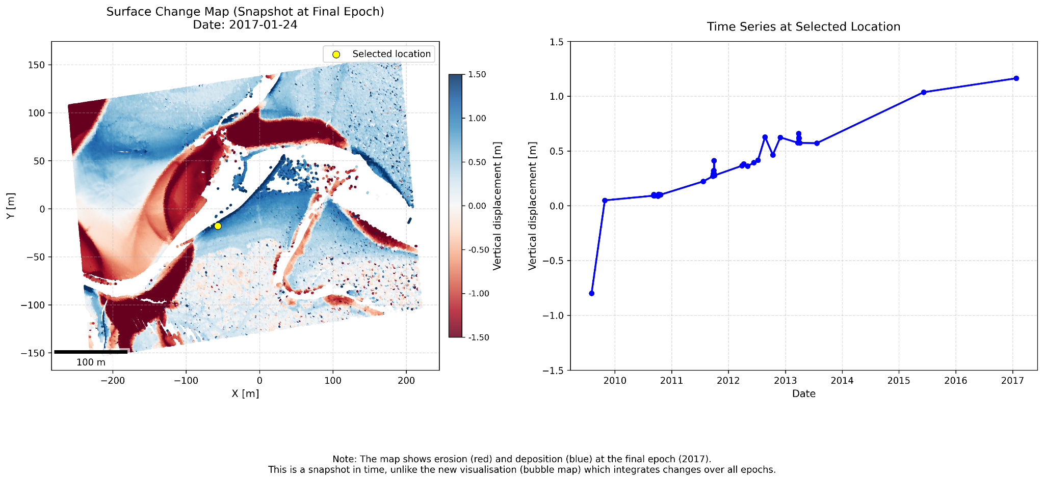**

**Bubble map**

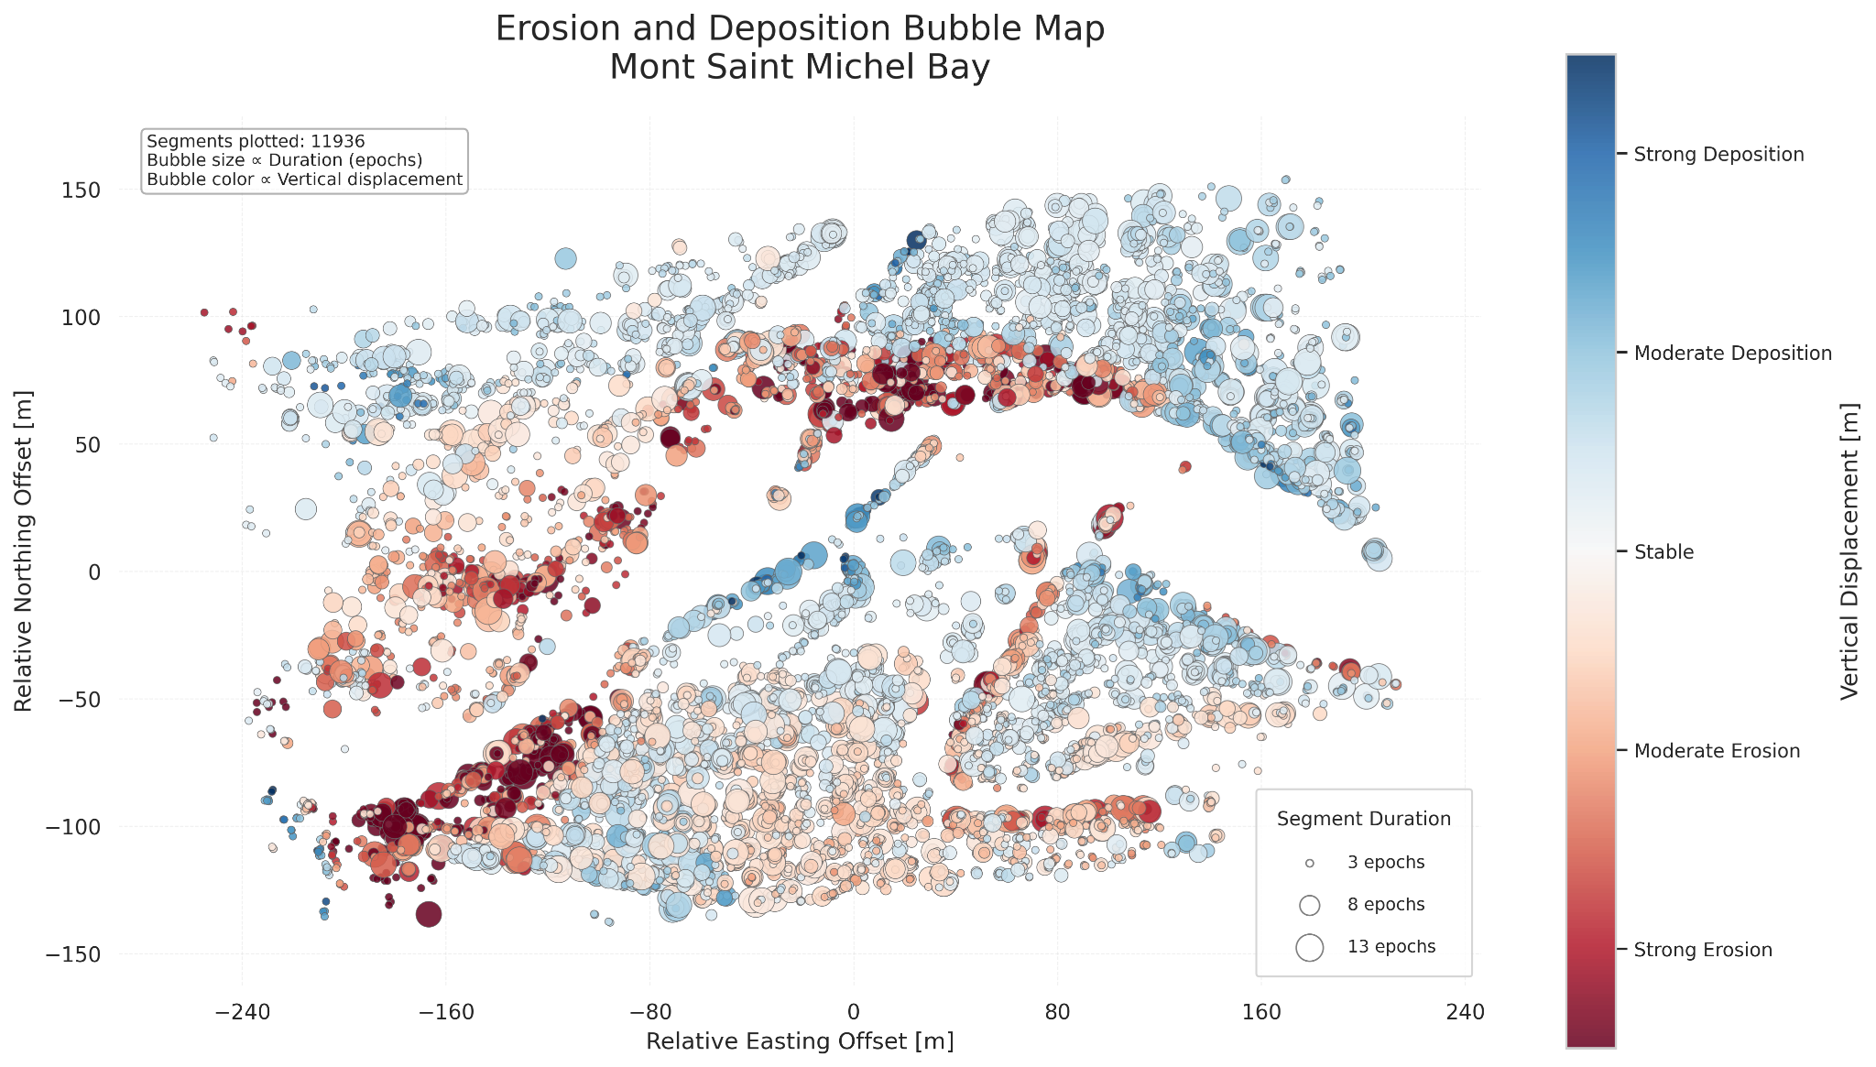

**Table and graph**

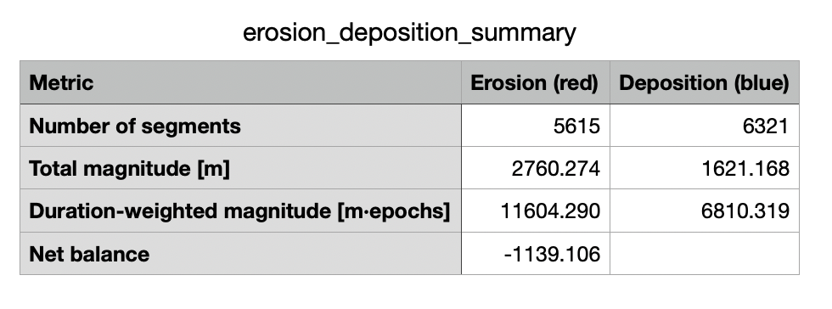

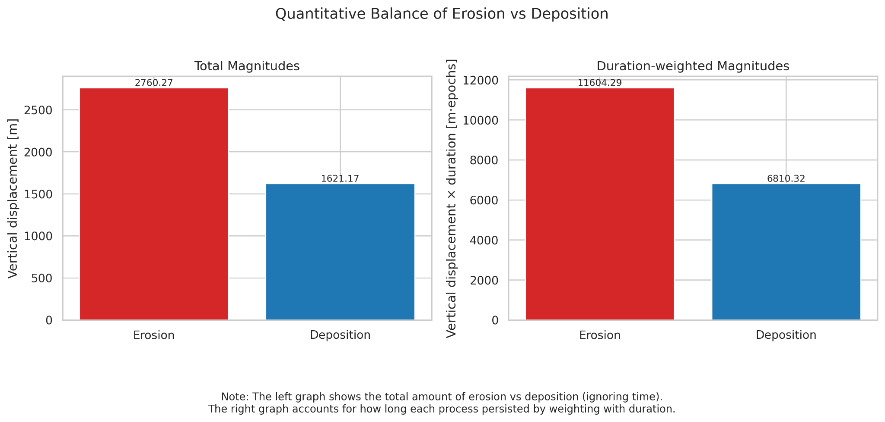

**Bubble map with zoom inset**

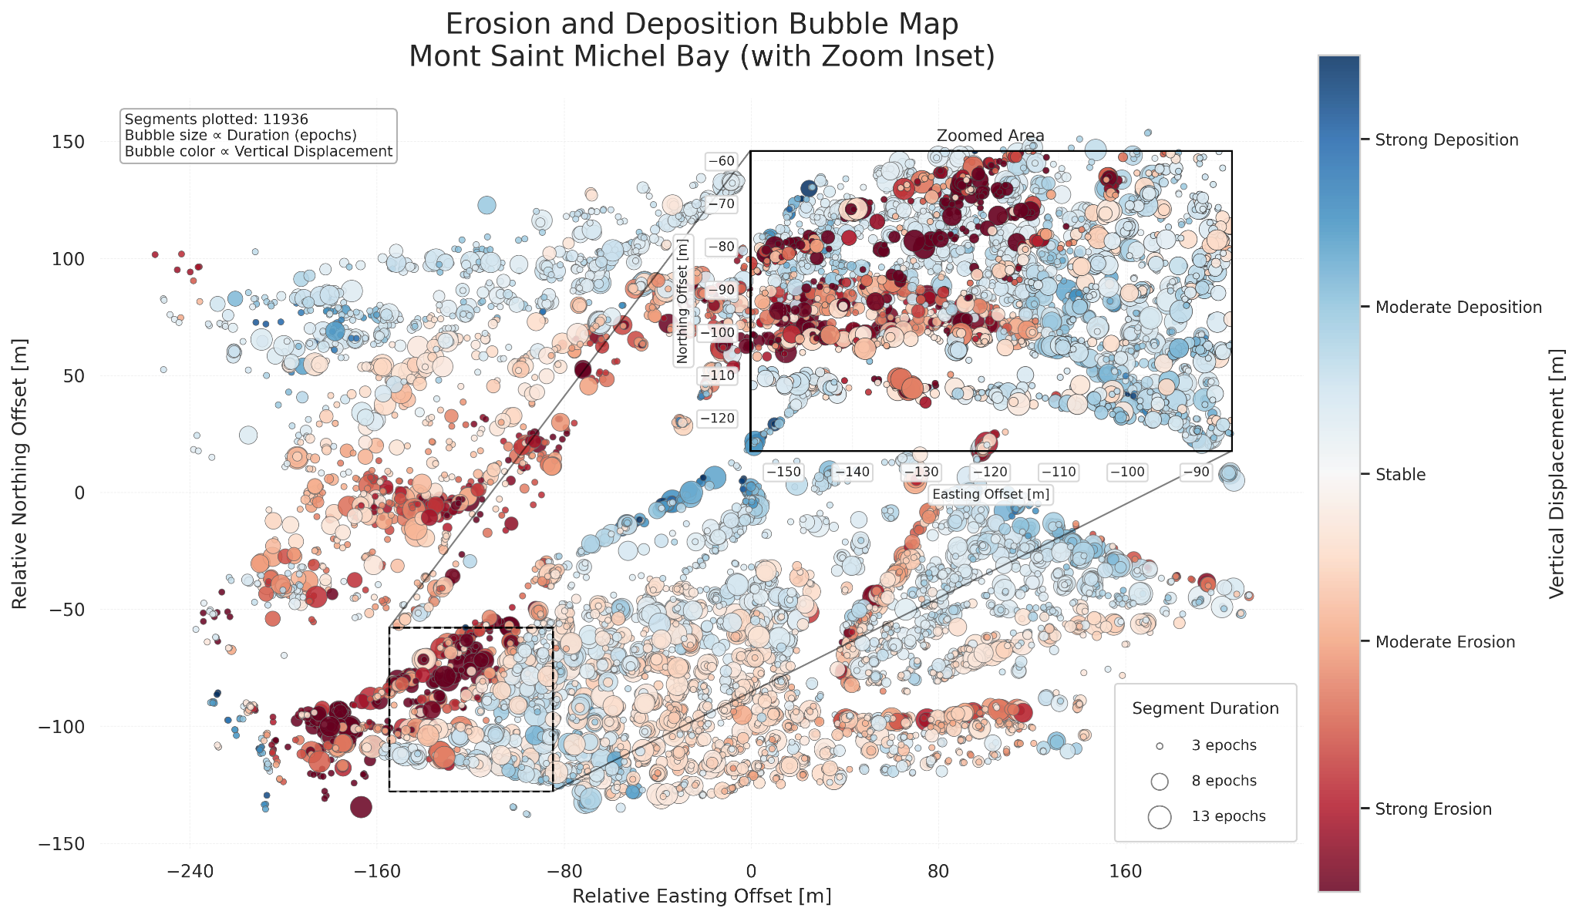

**Three panel bubble maps**

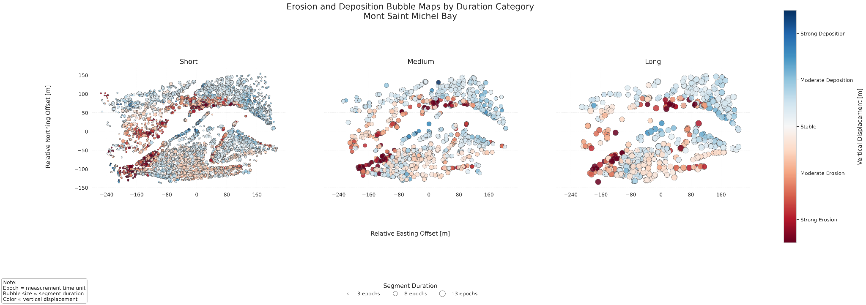

Animated Maps

### **Animated bubble Map w.r.t duration**

**Animated bubble Map w.r.t magnitude**



Interactive Maps

### **Interactive bubble Map w.r.t duration (html file format)**

<https://maryam-source.github.io/thesis-interactive-maps/interactive_map_duration.html>

### **Interactive bubble Map w.r.t magnitude (html file format)**

<https://maryam-source.github.io/thesis-interactive-maps/interactive_map_magnitude.html>

### **Interactive bubble Map w.r.t duration and magnitude (html file format)**

<https://maryam-source.github.io/thesis-interactive-maps/interactive_map_combination.html>

### **Interactive bubble Map w.r.t timestamps (html file format)**

<https://maryam-source.github.io/thesis-interactive-maps/interactive_map_timestamps.html>